Car Inventory Report

Jennifer Vongsyprasom

9/11/23

Top drivers by miles.

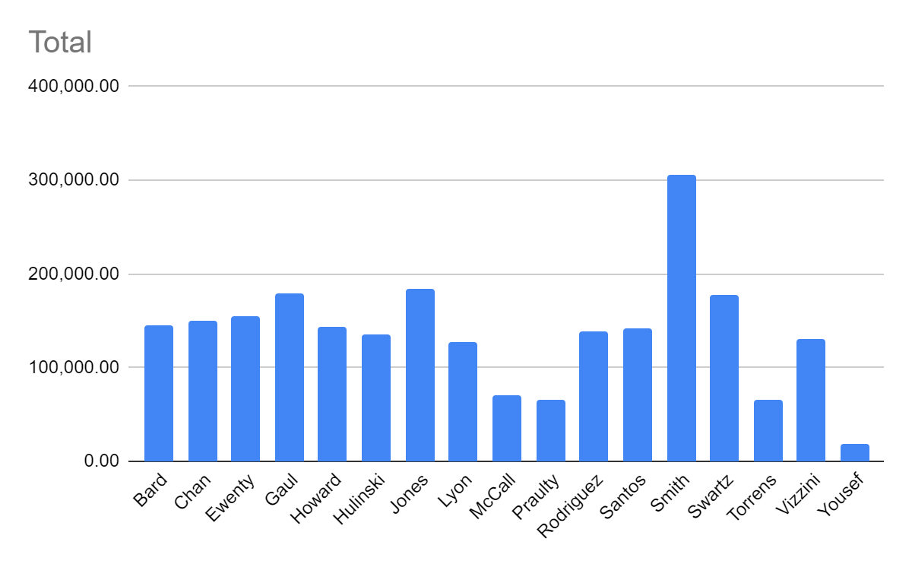

Scatter chart for the car inventory. Miles on each car.

